OPERATING SYSTEM LAB TASK 6

NAME: SYED MUZZAMIL WASEEM
SID: 11067
CID: 109134
QUESTION 1:
CODE:

#!/bin/bash
echo "enter first number"
read a
echo "enter second number"
read b
echo "before swapping a is $a and b is $b"
#swapping
a=$((a+b))
b=$((a-b))
a=$((a-b))
echo "after swapping a is $a and b is $b"

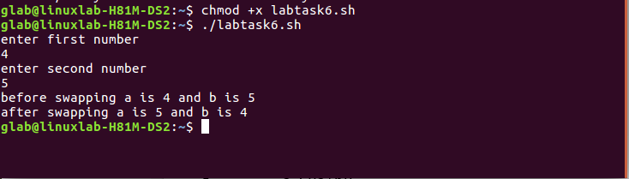
QUESTION 2:
CODE:

#!/bin/bash
echo "enter a character"
read c
if [[ $c =~ [A-Za-z] ]];
then
echo "Alphabet"
elif [[ $c =~ [0-9] ]];
then
echo "Number"
else
echo "Special Symbol"
fi

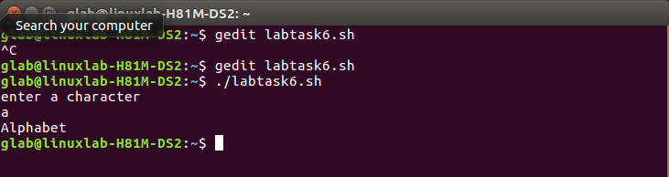

QUESTION 3:
CODE:

#!/bin/bash
echo "enter a number"
read no
i=1
ans=0
while [ $i -le $((no / 2)) ]
do
if [[ $((no%i)) -eq 0 ]]
then
ans=$((ans + i))
fi
i=$((i + 1))
done
if [ $no -eq $ans ]
then
echo "$no is perfect"
else
echo "$no is NOT perfect"

